**CPE223 – Signals and Systems**



**Lab # 8**

**To Reproduce the Continuous Time Fourier Transform (CTFT) Using MATLAB Function**

|  |  |
| --- | --- |
| **Name** | Muhammad Aizaz Arshad |
| **Registration Number** | 088 |
| **Class** | FA18-BCE-A |
| **Instructor’s Name** | Umair Shafique Khan |

**OBJECTIVE:**

* To trace the output response of Continuous Time Fourier Transform (CTFT) and verify different properties of CTFT using MATLAB.

**REQUIRED EQUIPMENT:**

**Software:**

* **MATLAB**

**METHODOLOGY:**

Fourier transform of signal is used for changing signal from time to frequency domain that is cyclic domain. In order to get back in time domain inverse Fourier transform is used.

Commands such as, fourier (function, w) and ifourier (function, w) is used for converting time domain into frequency domain and vice versa are used.

Different properties of Fourier transform were analyzed in this lab time reversal, time shifting, differentiation, integration and duality. Magnitude angle, real and imaginary part of a Fourier transformed signal were plotted in order to find out different output responses. Convolution was done with fourier transform.

**CONCLUSION:**

In this lab we basically computed and plot the output of continuous time fourier transform’s in MATLAB using different built in commands like fourier and ifourier because computing output can be difficult through integration for transformation of time domain signal. Moreover, In this lab we verify different CTFT’s properties by left and right hand side technique.

**IN LAB TASKS:**

**Question 1:**

syms t w % inlab task 1

x=exp(-t.^2);

a=fourier(x,w)

ezplot(a,w)

title('Fourier Transform')

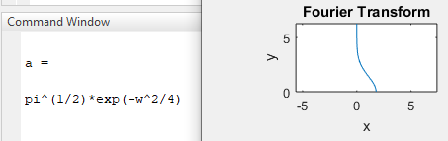

**Question 2:**

syms t w %inlab task2

X= (1/(1+j.*w));

x= ifourier(X,t)

ezplot(x,t)

title('Inverse Fourier Transform')

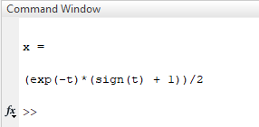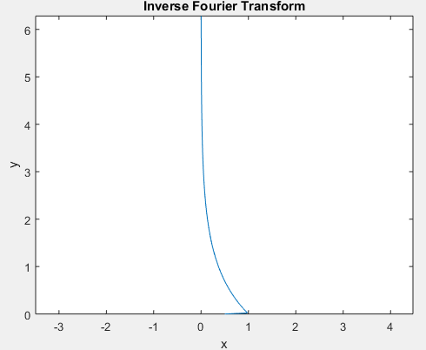

**Question 3:**

syms t w T %inlab task3

h2=heaviside(t);

x= exp(-t)*h2;

X= fourier(x,w)

X1= (1/(1+j.*w)) %previous example

x1= ifourier(X,t)

ezplot(X,w)

title('Fourier Transform e^-t.u(t)')

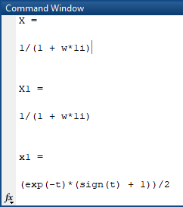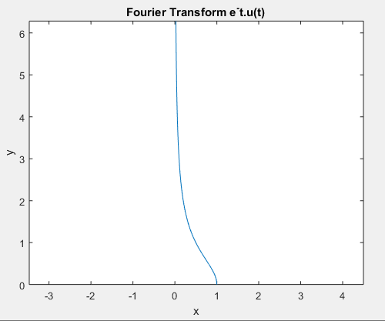

**Question 4:**

syms t w T %inlab task4

x= sinc(t);

X= fourier(x,w)

ezplot(X, [-10 10])

title('Fourier Transform sinc(t)')

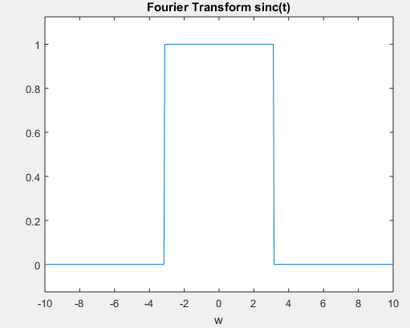

**Question 5:**

syms t w0 %inlab task5

w=-20:0.1:20

x=t.*exp(-3*t).*heaviside(t);

y=fourier(x,w)

y1=subs(y,t,w)

subplot(2,2,1)

plot(w,abs(y))

ylim([0 0.12]);

xlim([-20 20]);

title('magnitude')

subplot(2,2,2)

plot(w,real(y))

title('real')

subplot(2,2,3)

plot(w,imag(y))

title('imaginary')

subplot(2,2,4)

plot(w,angle(y))

title('phase')

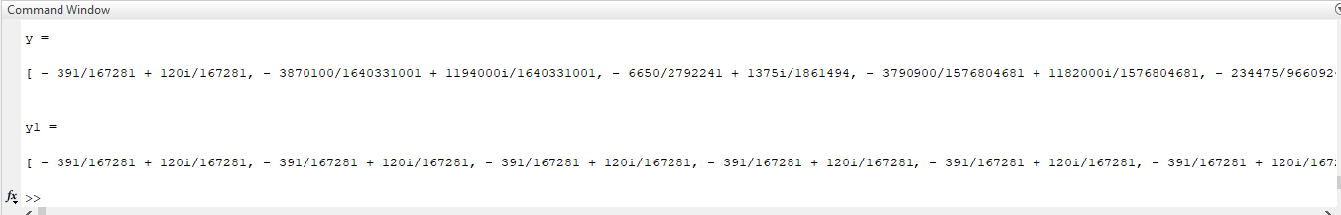

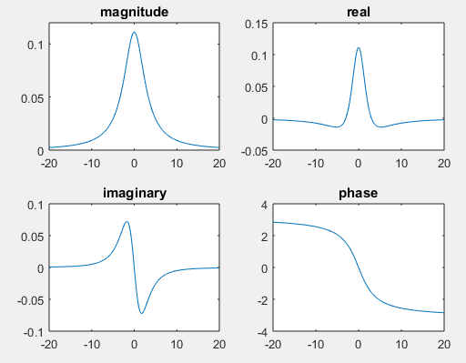

**Question 6:**

syms t w T %inlab task6

x= exp(-t)*cos(2*pi*t)*heaviside(t);

h= exp(-t)*heaviside(t);

subplot(3,3,1)

ezplot(x)

title('Signal x(t)')

subplot(3,3,2)

ezplot(h)

title('Signal h(t)')

fx= fourier(x,w)

fh= fourier(h,w)

subplot(3,3,3)

ezplot(fx,w)

title('Fourier Transform of x(t)')

subplot(3,3,4)

ezplot(fh,w)

title('Fourier Transform of h(t)')

convolution= fx.*fh

subplot(3,3,5)

ezplot(convolution,w)

title('Convolution using Fourier Transform')

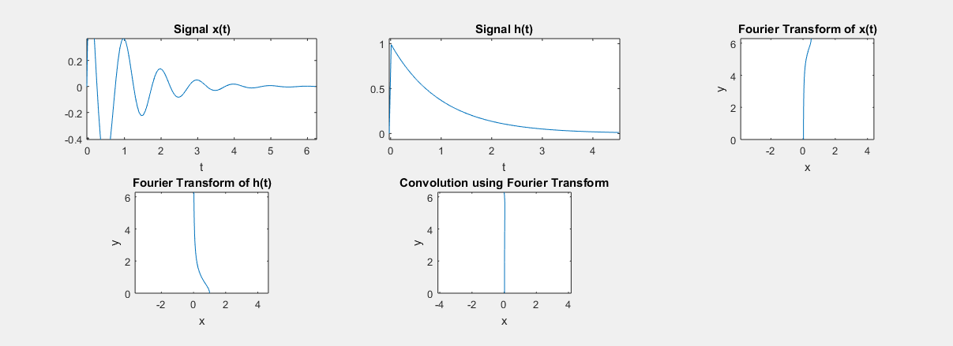

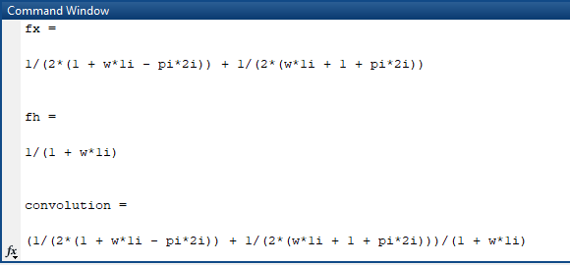

**Properties of Continuous Time Fourier Transform:**

**% LINEARITY**

syms t

a=1; w=2;

x=exp(-t.^2);

x1=a.*x;

LHS=fourier(x,w)

x2=fourier(x,w);

RHS=a.*x2

Answer=LHS-RHS

'linearity proved'

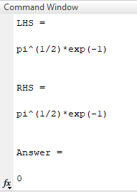

**%TIME SHIFTING**

syms t w

t0=3;

x=exp(-t.^2);

x1=exp(-(t-t0).^2);

LHS=fourier(x1,w)

subplot(2,2,1)

ezplot(LHS,w)

title('LHS')

X=fourier(x,w);

RHS=exp(-j.*w.*t0).*X

subplot(2,2,2)

ezplot(RHS,w)

title('RHS')

ANSWER=LHS-RHS

subplot(2,2,3)

ezplot(ANSWER,w)

title('LHS - RHS')

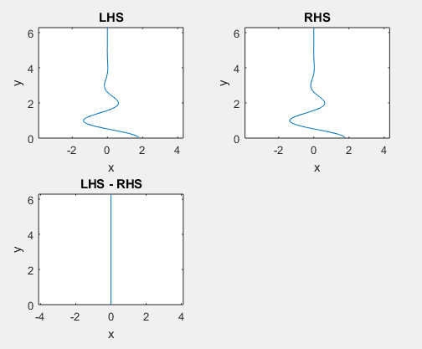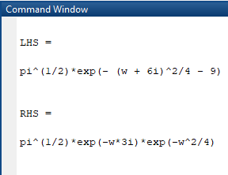

**% Frequency Shift**

syms t

syms t w

w0=3;

x=exp(-t.^2);

x2=exp(j.*w0.*t).*x;

LHS=fourier(x2,w)

subplot(1,2,1)

ezplot(LHS,w)

title('LHS')

f1=fourier(x,w);

RHS=subs(f1,w,w-w0)

subplot(1,2,2)

ezplot(RHS,w)

title('RHS')

ANSWER=LHS-RHS

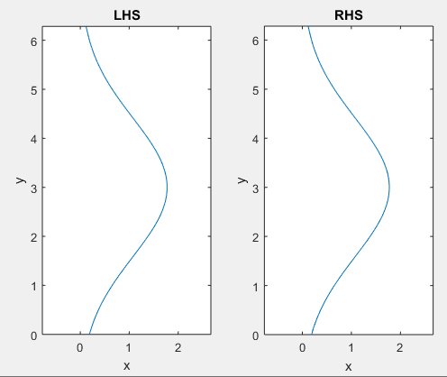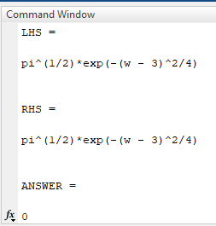

**% Scaling in Time & Frequency**

syms t w

b=5;

x=exp(-t.^2);

x1=exp(-(b.*t).^2);

LHS=fourier(x1,w)

f=fourier(x,w);

f1=subs(f,w,w./b);

RHS=(1./b).*f1

Answer=LHS-RHS

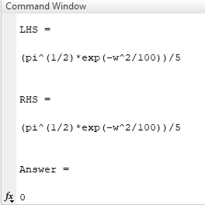

**% Time Reversal**

syms t w

x=exp(-t.^2);

x1=exp(-1.*(-t).^2);

LHS=fourier(x1,w)

f=fourier(x,w);

RHS=subs(f,w,-w)

Answer=LHS-RHS

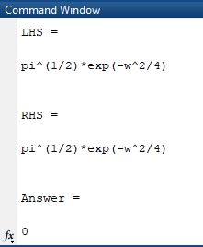

**%Differentiation**

syms t w

x=exp(-t.^2);

x1=diff(x);

LHS=fourier(x1,w)

f=fourier(x,w);

RHS=j.*w.*f

Answer=LHS-RHS

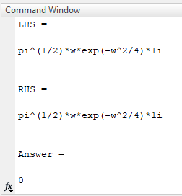

**% Integration**

syms t w d

x1=exp(-t.^2);

x=exp(-d.^2);

integration=int(x,d,-inf,inf); % or integration=int(x,d,-inf,t);

LHS=fourier(integration,w)

subplot(1,2,1)

ezplot(LHS,w)

title('LHS')

f=fourier(x1,w);

f1=(1./(j.*w)).*f;

a=subs(f,w,0);

f2=pi.*a.*dirac(w);

RHS=f1+f2

subplot(1,2,2)

ezplot(RHS,w)

title('RHS')

Answer=LHS-RHS

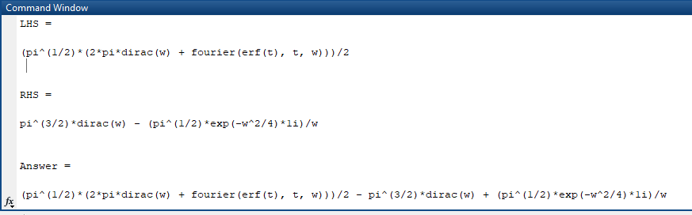

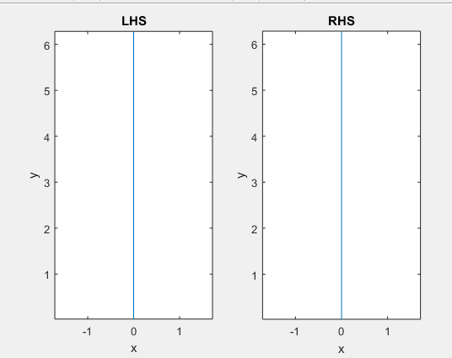

**% Duality**

syms t w

x=exp(-t.^2);

f=fourier(x,w);

f1=subs(f,w,t);

LHS=fourier (f1, w)

f2=subs(x,t,-w);

RHS=2.*pi.*f2

Answer=LHS-RHS

